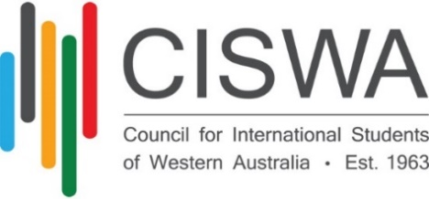

**SELECTION CRITERIA**

**WA International School Student of the Year**

The **CISWA WA International School Student of the Year Award** is about recognising the significant contribution that international students make to the Western Australian community.

CISWA are looking to acknowledge an international student, who has demonstrated academic excellence and has contributed to enhancing the student experience both on and off campus.

In selecting the recipient of this award, the student’s achievements and contributions during their time as an international student in Australia will be taken into consideration. Additional weight will be given to any activities which promote interaction with Australian students and with the local community.

**SELECTION CRITERIA**

* The student’s contributions and achievements
* Benefits to other students and/or the community of the student’s activities
* All community and volunteer work undertaken
* Previous awards and recognition
* Achievements as an individual or as part of a group or organization
* Demonstrated academic excellence – at least Credit average

**REFEREE QUESTIONS**

* **What is your relationship to the candidate?**
* Did you work with the candidate directly and what was it like to work with the student?
* **Can you describe the candidate’s school performance/rapport with other students?**
* **What are the candidate’s strengths and weaknesses?**
* Why do you think he should win the award?