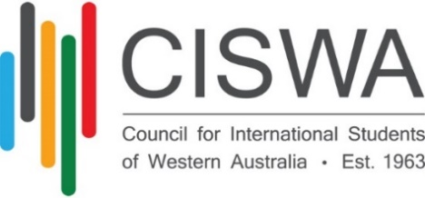

**SELECTION CRITERIA**

**WA International VET Student of the Year Award**

The **CISWA WA International VET Student of the Year Award** is designed to recognise the significant contribution of an international student to the Western Australian community.

CISWA is seeking to acknowledge an international VET student who has demonstrated academic excellence and has contributed to enhancing the student experience both on and off campus.

In selecting the recipient of this award, the student’s achievements and contributions during their time as an international student in Australia will be considered. Additional weight will be given to any activities that promote interaction with Australian students and with the local community.

**SELECTION CRITERIA**

* Be enrolled or completed a VET qualification in 2024, in Western Australia
* Demonstrated contribution to enhancing the student experience both on and off campus.
* Demonstrated contribution to and engagement with, the local community.
* Involvement in activities that promote interaction of international students with Australian students.
* Demonstrated academic excellence.
* Degree of difficulty of the achievement – for example, in the face of hardship/adversity
* Voluntary work (beyond paid employment)
* Previous awards and recognition, if any.
* Achievements may be as an individual or as part of a group or organisation.
* “X Factor”

**REFEREE QUESTIONS**

* **What is your relationship to the candidate?**
* Did you directly supervise/teach/work with the candidate?
* **Can you confirm the candidate’s information – either study record, employment dates, and/or volunteering record, as appropriate.**
* **Can you describe the candidate’s academic performance/rapport with families/students/community groups?**
* **What are the candidate’s strengths and weaknesses?**
* Why do you think s/he should win the award?