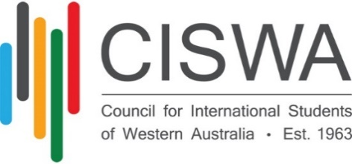

**SELECTION CRITERIA**

**WA International Education Program of the Year Award**

This award recognises the work of an individual or team in a Western Australian education institution that has contributed to the welfare or support of international students. For example, communication support programs, pathways initiative, or social inclusion activities.

Additional weight will be given to any activities which promote interaction with Australian students, with the local community or help students settle into life in Australia.

* Is it innovative?
* Does it benefit international students?
* Does it integrate with local students?
* What reach in terms of number of students (of the cohort)
* Is it replicable?
* How readily accessible is it to international students? i.e. preferably free of charge, well promoted